Prevention, Retention and Contingency Tracking
User Guide
Contents
Logging into PRC 3
Reset password (External users only) 4
Recipient Services 7
Searching for a Recipient 7
Adding a Recipient 7
Editing a Recipient 8
Deleting a Recipient 8
Adding a Service 9
Editing a Service 10
Viewing a Service 10
Deleting a Service 11
Reports 11
Report Parameters 12
Report Descriptions 13

Logging into PRC

Logging into the PRC application
Step 1. In your browser, navigate to the PRC website ( PRC.jfs.ohio.gov).

For state and county users:

Step 2. Log into the PRC application using your network id and password.

For external users:

Step 2. Log into the PRC application using your PRC assigned Login Id and your password.

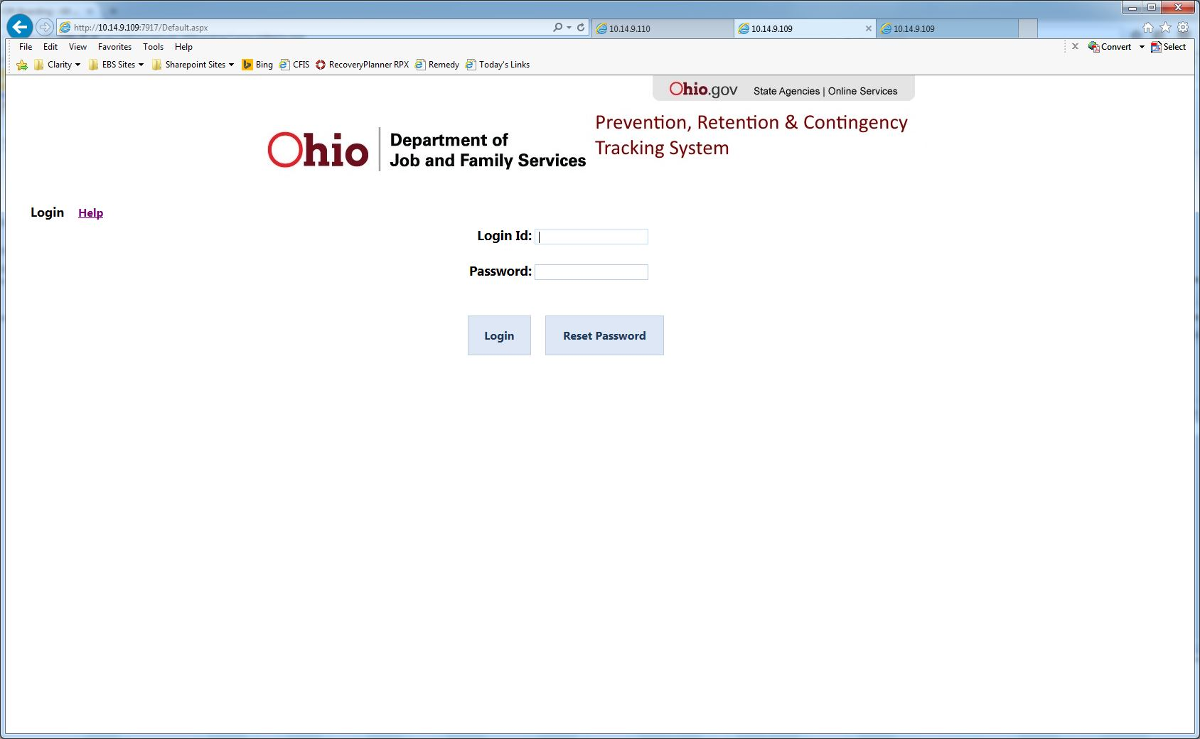

Step 3. Click the Login button.

Step 4. If your credentials were entered correctly, you will be taken to the PRC main screen.

Reset password (External users only)

Note: Use this feature if you are a new external user and do not yet have a system password established or have forgotten your login password.

Step 1. Enter your Login Id and click the Reset Password button. If you have a valid e-mail address on file, an e-mail will be sent to that e-mail address with a temporary password.
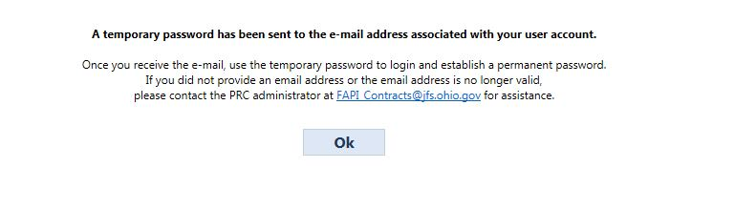
Step 2. Use the temporary password in the e-mail to login.

Step 3. You will be prompted to enter a permanent password.
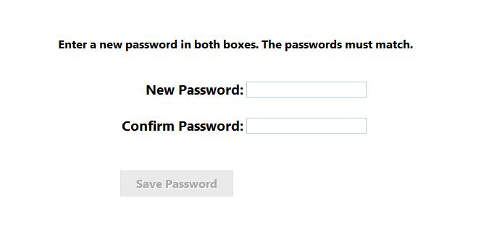
Step 4. Enter a new password in the new password and confirm password text boxes.

An indicator will display if the passwords do or do not match.
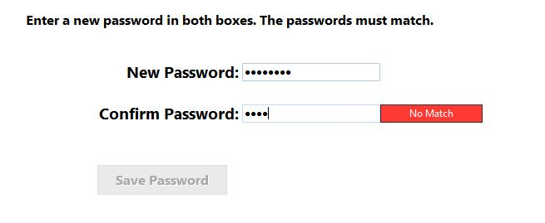
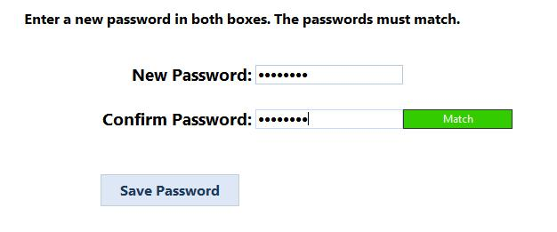
Step 5. Once the passwords match, click Save Password.

After successfully logging into PRC you will see the main PRC page:

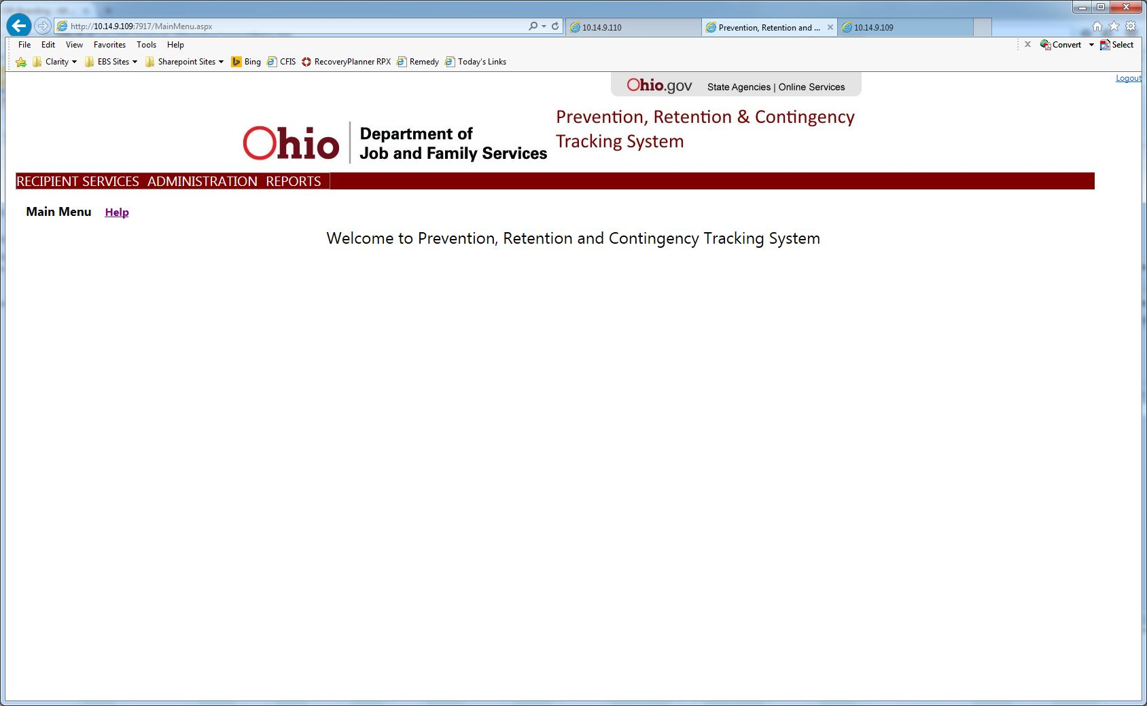

Recipient Services
Click on the RECIPIENT SERVICES link in the main menu to go to the Recipient Services page. From this page you can manage Recipients and their Services (see image below).

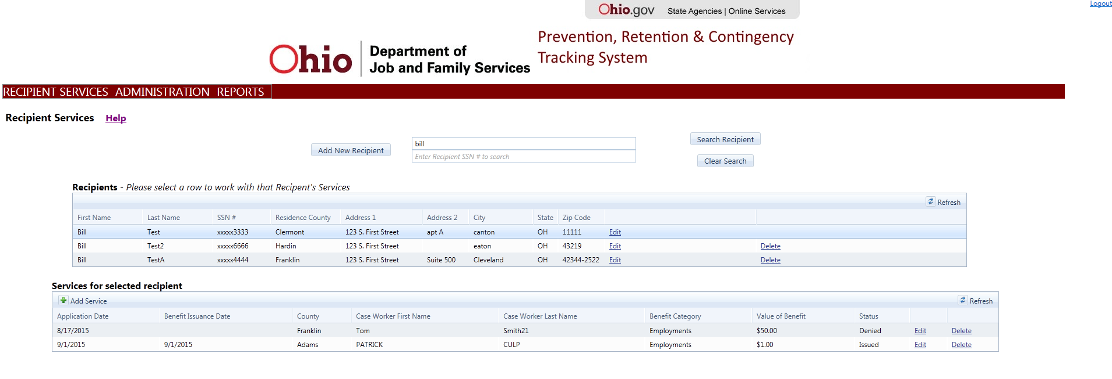

Searching for a Recipient
Before adding a Recipient, you are required to search for the Recipient to ensure they are not already in the PRC system.

Search for a Recipient by:

Step 1. Enter all or part of the Recipient’s first or last name or all or the beginning part of their SSN and click the Search Recipient button.
Step 2. A list of Recipients matching the search criteria will be displayed in the Recipients grid (see image below).

You can start a new search by clicking the Clear Search button.

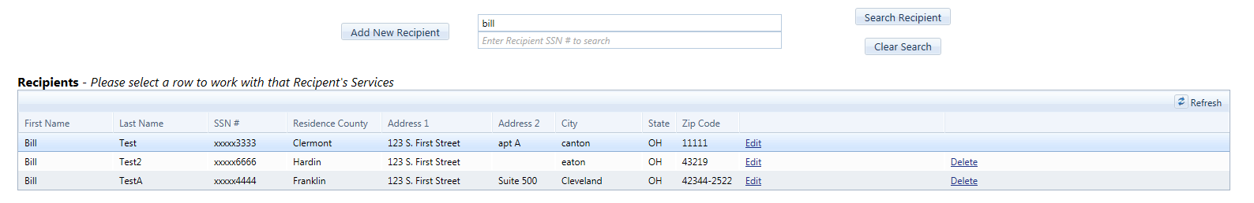

Adding a Recipient
Add a Recipient by:

Step 1. Click the Add New Recipient button in the Search area.

Step 2. The Add Recipient line will be displayed (see image below).

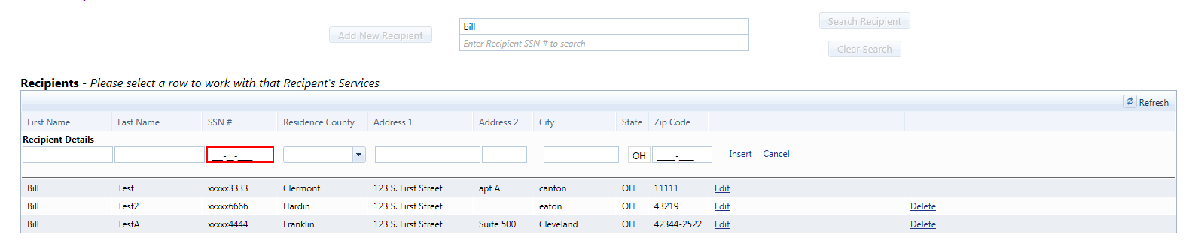

All fields except for Address 2 are required.

Step 3. Click the Insert button to save the Recipient.

Cancel adding by clicking the Cancel button.

Editing a Recipient
Edit a Recipient by:

Step 1. Click the Edit button in the Recipient search grid of the Recipient line you wish to edit. The Edit Recipient line will be displayed (see image below).

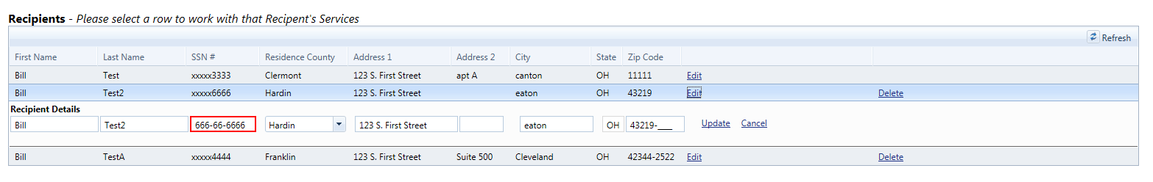
Step 2. Make any needed changes to the Recipient information and then click the Update button to save the changes.

Cancel changes by clicking the Cancel button.

Deleting a Recipient
A Recipient may be deleted if they have no Services recorded.

Delete a Recipient by:

Step 1. Click the Delete button in the Recipient search grid of the Recipient line you wish to delete.

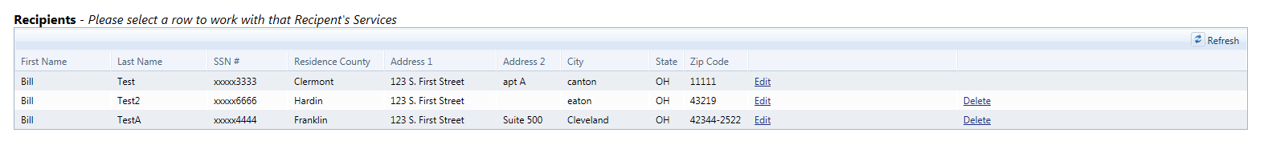

Adding a Service

Add a Service by:

Step 1. Click the Add Service button in the Services for selected recipient search grid.
Step 2. The Add Service panel will be displayed (see image below).

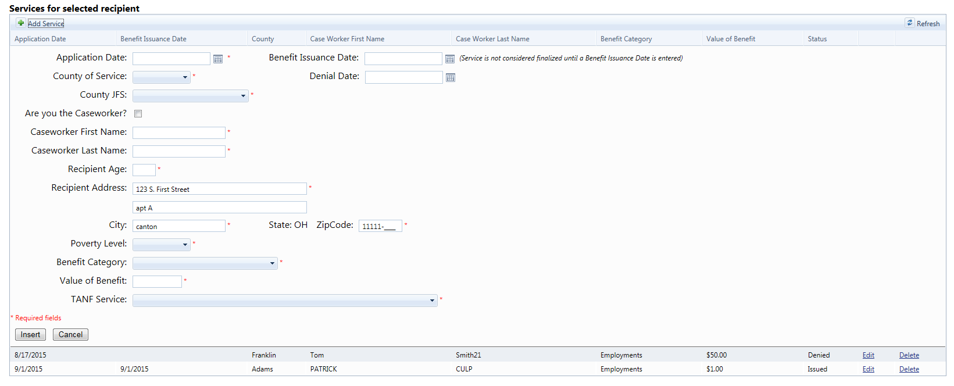

At a minimum, you must enter all fields that are marked as required. Required fields are indicated with a red asterisk (*) in front of each field.

Step 3. Click the Insert button to save the Service.

Cancel adding by clicking the Cancel button.

Editing a Service
Edit a Service by:

Step 1. Click the Edit button in the Services for selected Recipient search grid of the Service line you wish to edit. The Edit Service panel will be displayed (see image below).

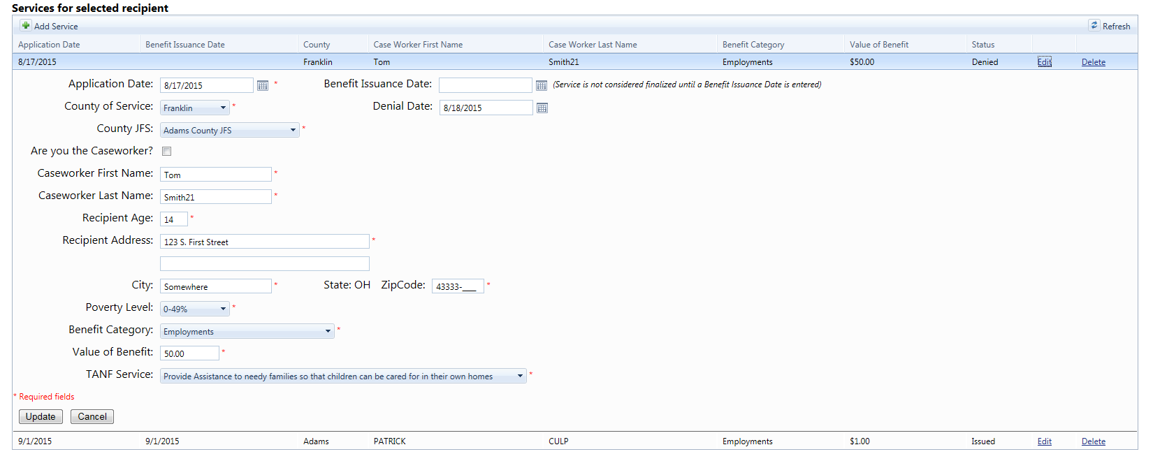

Step 2. Make any needed changes to the Service information and then click the Update button to save the changes.

Cancel changes by clicking the Cancel button.

Viewing a Service
Services with Benefit Issuance Dates older than 14 days ago can only be viewed.

View a Service by:

Step 1. Click the View button in the Services for selected recipient search grid of the Service line you wish to edit. The View Service panel will be displayed (see image below).

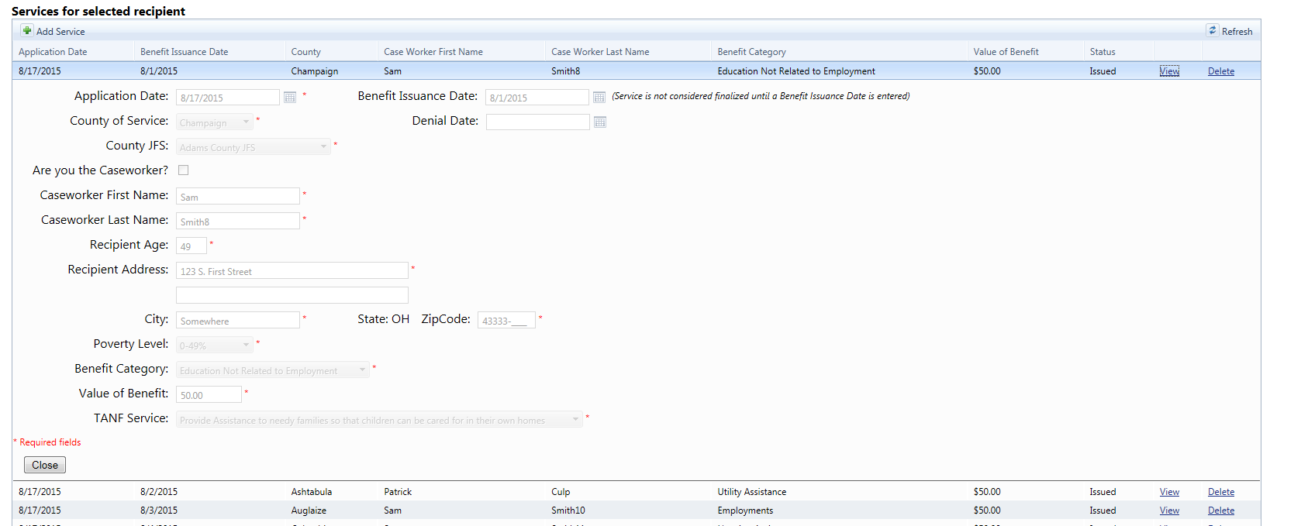

Step 2. When done, click the Close button to close the panel.

Deleting a Service
Delete a Service by:

Step 1. Click the Delete button in the Services for selected recipient search grid of the Service line you wish to delete.

Reports
Click on the REPORTS menu option to access the reports page (see image below).

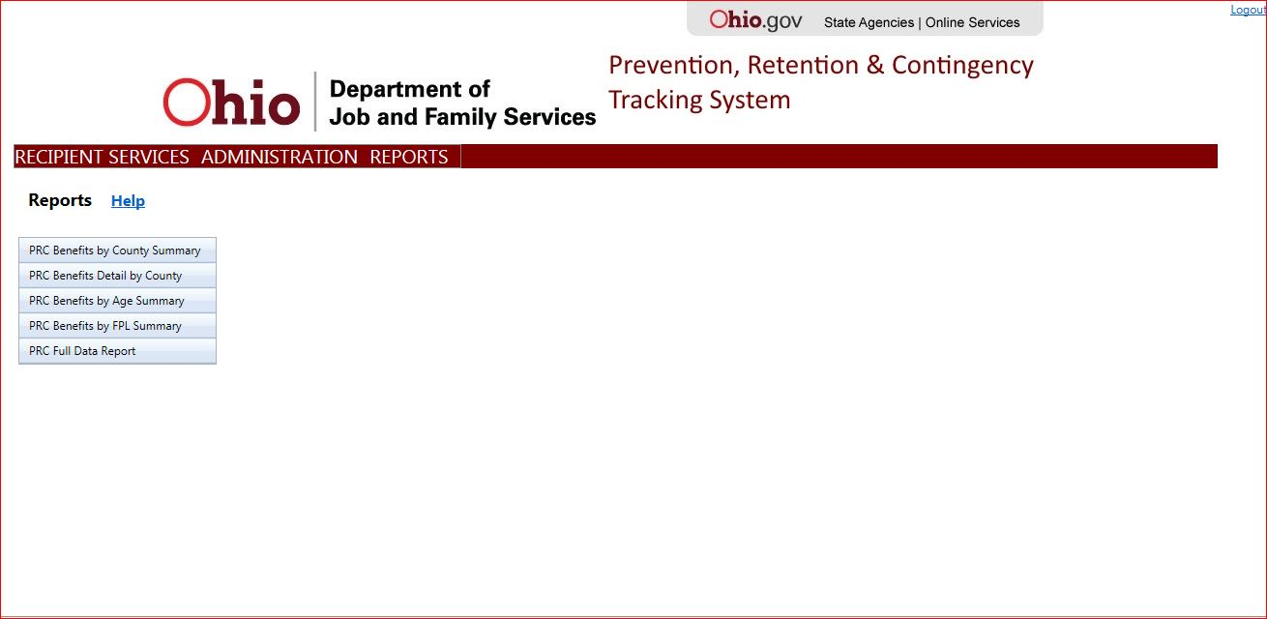

Report Parameters
Some reports have parameters that can be set to indicate which data is desired in the report. You can select which Benefit Categories you want as well as which counties you want to report against (see image below).

County and External users are limited to reporting on the county with which they are affiliated.

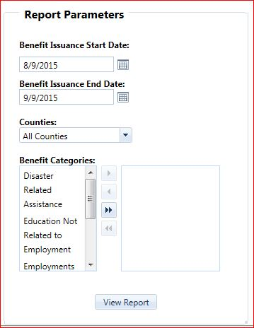

Running a report:

Step 1. Select the report from the list on the left.

Step 2. If report criteria is available, select the report criteria if needed.

Step 3. Click the View Report button.

Report Descriptions
PRC Benefits by County Summary | This report shows information either at a statewide level or county level (depending on user access). For state users, this report is filterable by County and benefit issuance date.
PRC Benefits Detail by County | This report shows information either at a statewide level or county level (depending on user access) and is filterable by one or multiple benefit Categories and issuance date.
PRC Benefits by Age Summary | This report shows a benefit summary by Age in each county. For State users, the report is filterable by county and benefit issuance date.
PRC Benefits by FPL Summary | This report shows a benefit summary by FPL in each county. For State users, the report is filterable by county and benefit issuance date.
PRC Full Data Report | This report shows detail recipients and services data in each county. For State users, the report is filterable by county and benefit issuance date.

